The Transport Layer

Bogdan Tatu – Gr. 3.1

1. Statistics
   1. 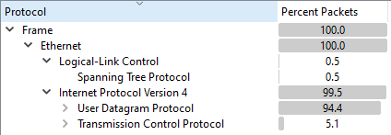UDP – 94.4% ( I was on discord at the time )
   2. I/O Graph
      1. 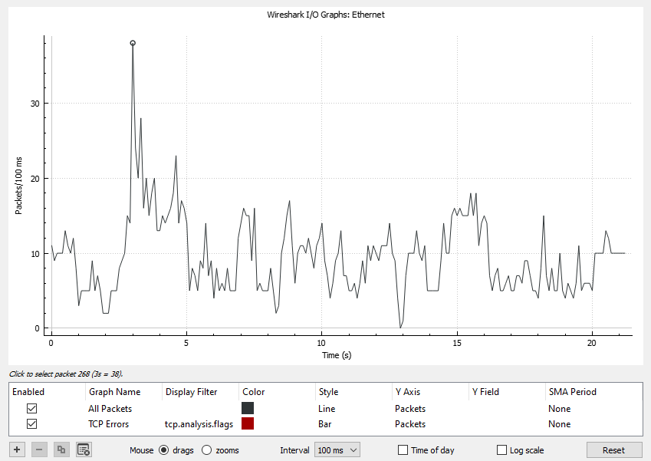38 packets – 3s after start
      2. 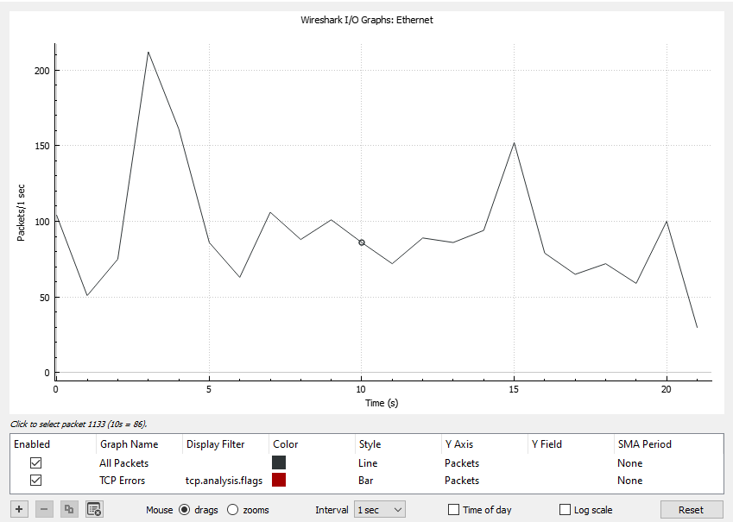Second 10: 86pks/s
2. UDP

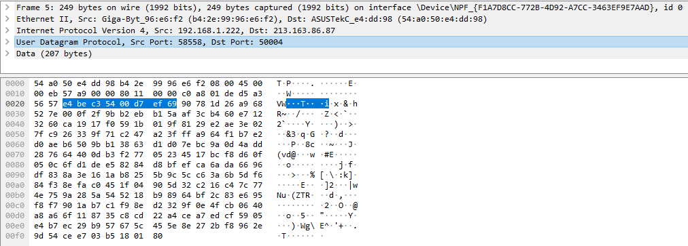3. UDP Header Length: 8 bytes

4. 4th UDP Frame:

* Source Port: 50004
* Destination Port: 58558



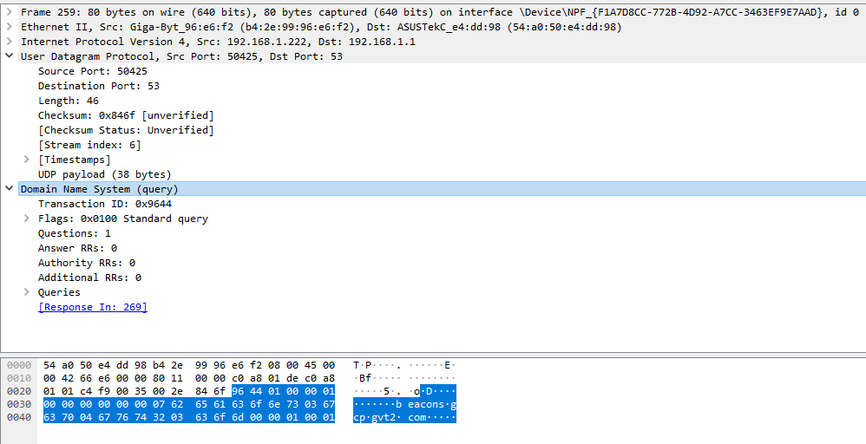5. DNS Headers Length: Frame Length – Payload = 80 – 38 = 42 bytes

1. TCP

6. SRC Socket 10th TCP Frame: 95.172.70.134:12975

SRC IP Address: 95.172.70.134

SRC TCP Port: 12975

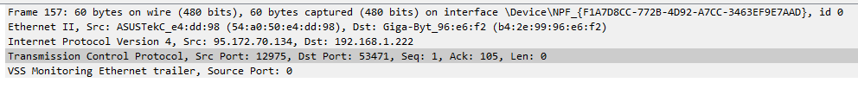

7. Difference between SYN and SYN-ACK

SYN Time: 1.782561 seconds

SYN-ACK Time: 1.784650 seconds

Difference: 0.002089 seconds

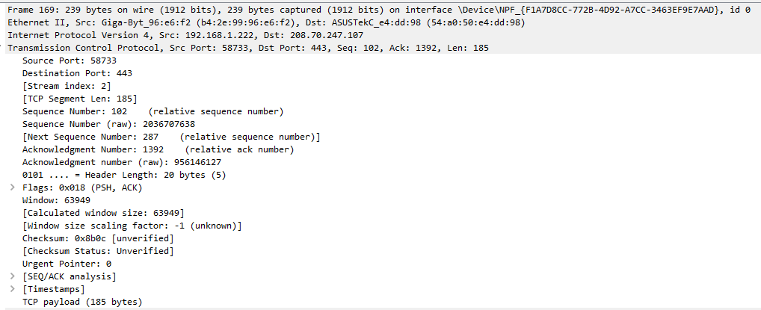8. Sum of all Headers TCP Packet: Frame Length – Payload = 239 – 185 = 54 bytes